Table of contents
1. Introduction. 2
2. Purpose of productivity. 2
3. Priority of tasks and productivity using task priority. 2
4. Productivity on team view using score only. 4

Introduction.
The purpose of this document is to specify the method to be measured productivity of team. Provides information support reader to understand why and how to define productivity of organization (team) and provide some resolution to be used in improving productivity in future work.
The data provided in this assignment which is obtained from the Effort log, meeting minute and evaluate member table of team were collected weekly.
Outputs (products) of team assignment are used to measure are document, tasks and earned score.

Purpose of productivity.
Help PM evaluate effectiveness of team work or individual.
Help PM define the standard for a perfect team.
Help PM make decision to improve team or individual performance.

Priority of tasks and productivity using task priority.
- For individual:
- Each assignment, we divide them into tasks. To evaluate size of work we base on completed tasks in before assignments. But problem is all tasks in assignment are not the same so define priority for each task is necessary.
- Evaluate spent effort for each task of each assignment will help us to define productivity of team.
The following table will describe priority and point of each task in all team assignments. (Statistics base on history data of team).
Assignment | Task | Point | Role
1 | Make roles and responsibility | 1 | Tin
1 | Make process | 1 | Son
1 | Schedule for 15 weeks | 1 | Tam
1 | Review & integrate | 1 | Huyen
1 | Review schedule for 15 weeks | 1 | Van
2 | Make assignment | 3 | All
2 | Integrate | 1 | Huyen
3 | Make assignment | 3 | All
3 | Integrate | 1 | Son
4 | Make assignment | 3 | All
4 | Integrate | 1 | Tam
5 | Make WBS | 1 | All
5 | Schedule | 3 | All
5 | Network diagram | 1 | All
5 | Integrate | 1 | Tin
6 | Individual productivity | 2 | Tin
6 | Team productivity | 2 | Son
6 | How to improve productivity | 2 | Tam
6 | Integrate | 1 | Huyen

How can we know priority of these tasks? – We base on the complexity of this task. Example: with assignments that cannot be divided into tasks, the complexity of it is HIGH, so its point is 3. And if can be divided into task, each this task just has 1 point. But in some special task, we must use brain storming method to make decision how many point for each task.
Example for using (metrics): in assignment 1, Tin and Son do 2 tasks have same priority. Tin spent 2 hours for his task; Son spent 4 hours for his task. We get Tin’s (or Son) score multiply with his task priority point and divide into his spent hour.
- TIN: Score is 475. Productivity = 475*1/2
- SON: Score is 950. Productivity = 950*1/4
2 results are same. So their performance is the same. But if Tin spent hour is 4 hours then productivity of Son is higher than Tin.
Metric: Score of member * priority point of his (or her) task / spent hour.
Bring result to compare to the other members, the higher score, the higher performance.
- For team:
Like metric for individual.
Metric: Score of team * total priority point of this assignment / total spent hours of all members.
Result of metric is bring to compare to the other teams or compare to plan, the higher score, the higher performance.
- There are three standards to evaluate productivity:
- Evaluate productivity against the planned
    - Example: Implementation plan is 4 hours but actually is 2 hours. So increased productivity
- Evaluation productivity of this assignment with the previous assignment
    - Example: Implementation this assignment is 6 hours but actually is 5 hours. So increased productivity if score of two assignments are equal.
- Evaluate productivity between the teams. We get the productivity of the best team and productivity of the worst team divide into 2. That is our standard.

Productivity on team view using score only.
Productivity is a measurement; help developers measure their effectiveness of work. The simplest way to define productivity is measure OUTPUT/INPUT. In software, this is SIZE/EFFORT. But define exact size or effort in software is a hard work.
In this assignment, we have to define what is the size and effort of our team work.
The size of work can be measured by output of it. We assume our output (product) is score of this assignment. The higher score, the bigger size.
The effort of work can be measured by number of spent hour in assignment of all members.
I will describe how I can give my idea about productivity in following picture. Using GQM approach.
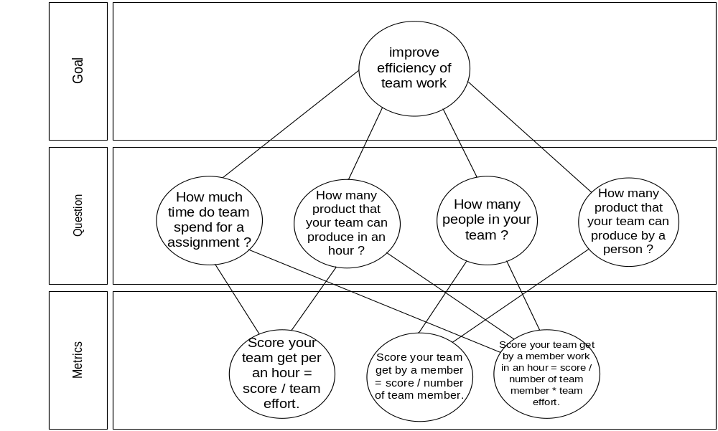
With above set of metrics we can use to measure our team effectiveness, and bring our measurement results compare to the others team.

